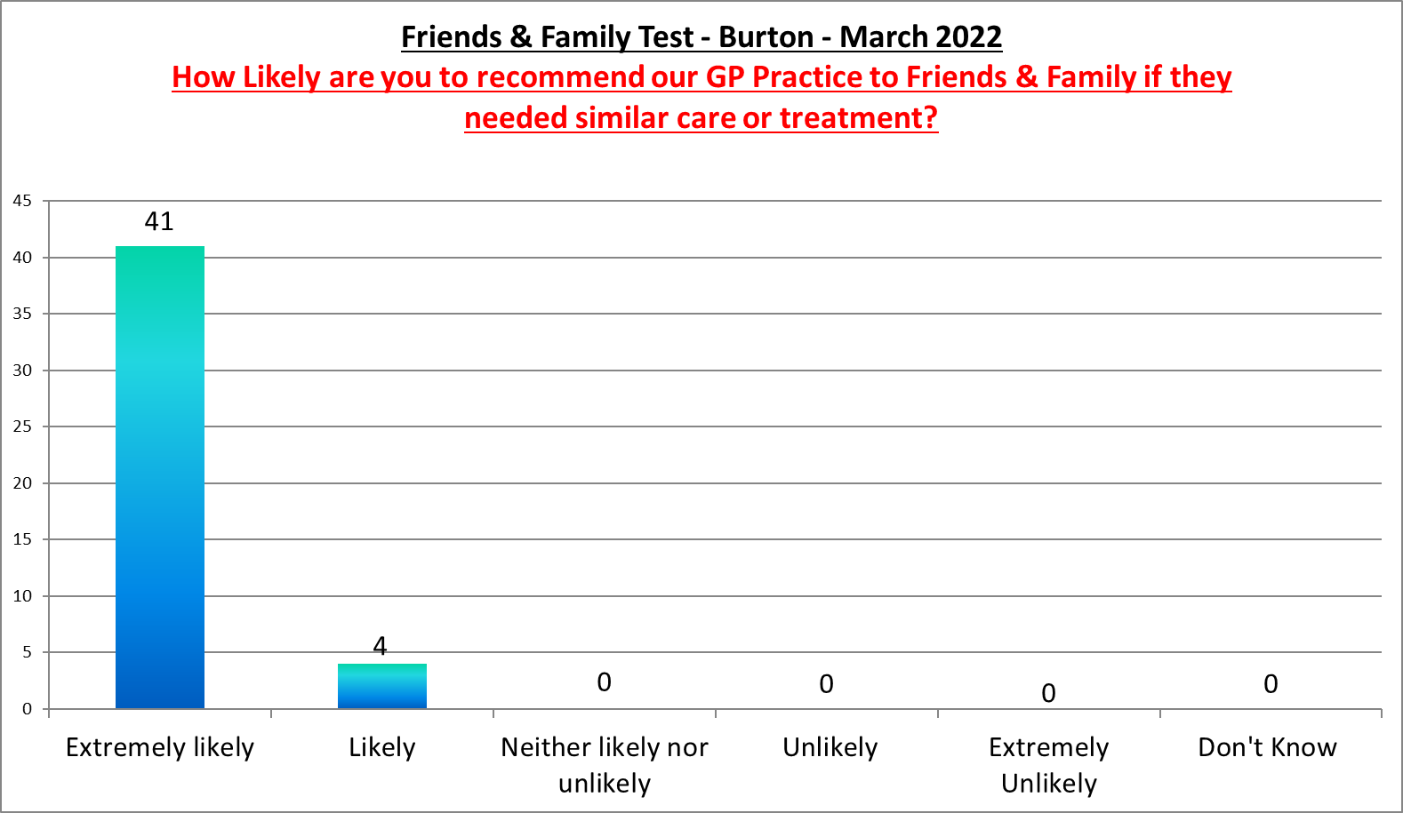

Burton Surgery
Positive Comments
Very efficient and pleasant service delivery in respect of blood sample taken and future appointment scheduling.
Negative Comments

